REPORT ON FINANCIAL PERFORMANCE

FOR THE PERIOD 1 JANUARY – 30 SEPTEMBER 2023

Zagreb, November 2023

RESULTS OF THE GROUP

BREAKDOWN OF THE MOST SIGNIFICANT FINANCIAL INFORMATION OF hbor GROUP
-in millions of euros-

 | 2021 | 2022 | 30 September 2023
Total assets | 3,753.2 | 3,857.0 | 3,941.4
Gross loans | 3,494.5 | 3,703.4 | 3,878.2
Total equity | 1,403.8 | 1,422.2 | 1,473.0
 | 1 January – 30 September 2021 | 1 January – 30 September 2022 | 1 January – 30 September 2023
Total income | 72.0 | 70.3 | 92.4
Total expense | (39.8) | (51.1) | (41.6)
Profit | 32.2 | 19.2 | 50.8
Interest income calculated on the basis of effective interest rate method | 65.3 | 63.2 | 68.3
Interest expense | (18.8) | (15.7) | (19.6)
Net interest income | 46.5 | 47.5 | 48.7

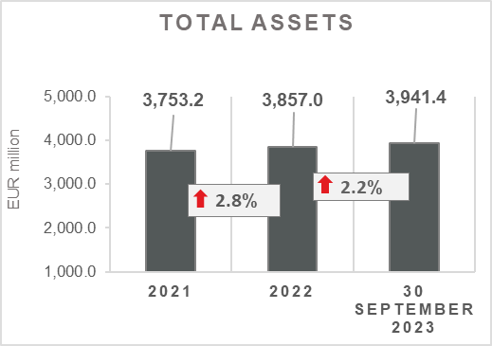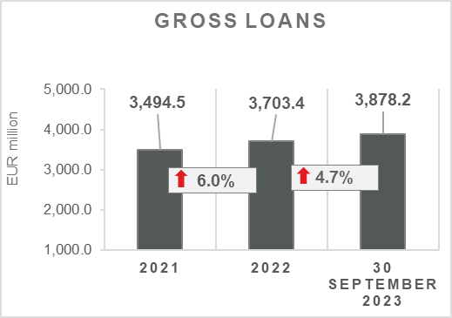

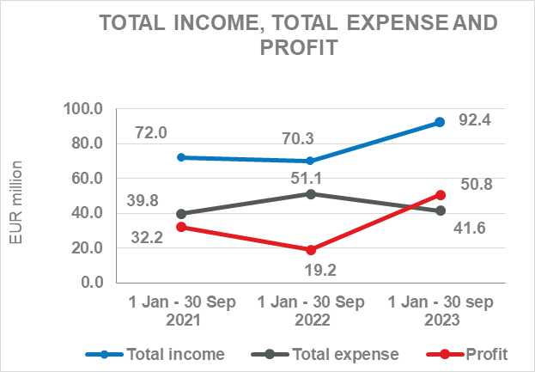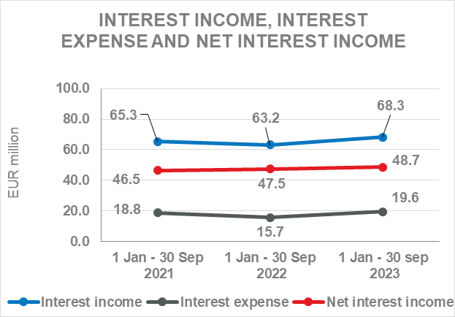

Results of the Group

In the period 1 January – 30 September 2023, the HBOR Group generated profit after tax in the amount of EUR 50.8 million.

Pursuant to the provisions of the Act on HBOR, the parent company is exempt from income tax and income tax liabilities arise exclusively from the activities of the other members of the Group.

In the period 1 January – 30 September 2023, total income on consolidated basis amounted to EUR 92.4 million, whereas total expenses amounted to EUR 41.6 million.

The consolidated total income increased by 31.4 percent, whereas total expenses decreased by 18.6 percent compared to the same period previous year due to the developments in total income and expenses of the parent company.

In the structure of income of the Group, the largest portion, i.e. 73.9 percent, relates to interest income as a result of operations of the parent company.

In the part of total expenses, the major part relates to interest expenses (47.1 percent) and operating expenses (46.9 percent) arising from the operations of the parent company.

The consolidated operating expenses in the period 1 January – 30 September 2023 amounted to EUR 19.5 million and consisted of general and administrative expenses and other operating expenses.

On 30 September 2023, the Group had 430 employees (on 30 September 2022: 397 employees).

Assets and liabilities of the Group

Total assets of the Group on consolidated basis amount to EUR 3,941.4 million, an increase of 2.2 percent compared with the beginning of the year. The reasons for such tendency are stated in the description of HBOR’s financial performance.

In the structure of assets, the major portion relates to the lending activities of the parent company, i.e. net loans account for 86.9 percent of total assets.

Total liabilities and total equity as at 30 September 2023 amount to EUR 3,941.4 million, of which amount total liabilities equal EUR 2,468.4 million, i.e. 62.6 percent.

In total liabilities and total equity of the Group, the major portion, i.e. 55.1 percent, consists of borrowings of the parent company.

At the end of the reporting period, total equity on consolidated basis amounted to EUR 1,473.0 million and accounted for 37.4 percent of total liabilities and total equity of the Group.

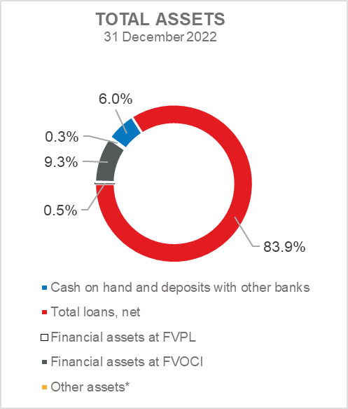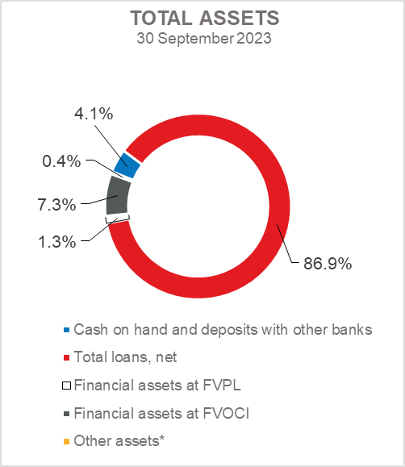

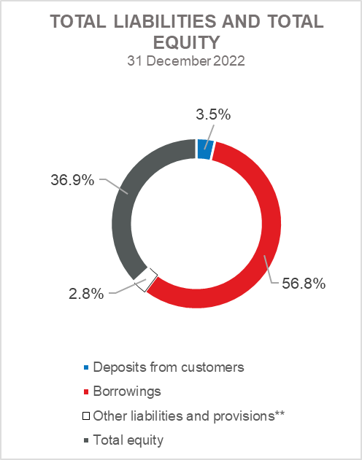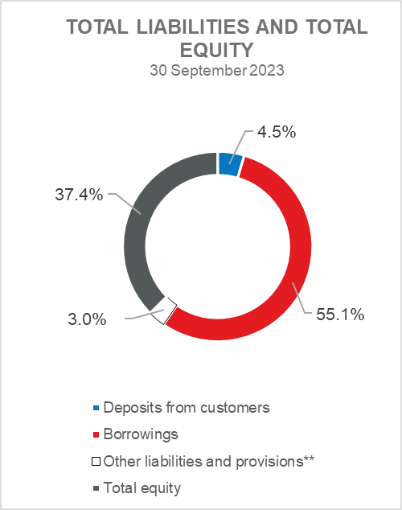

*Property, plant and equipment and intangible assets, Foreclosed assets, Debt securities at AC and Other assets.
**Provisioning includes provisioning for guarantees, commitments and other liabilities.

RESULTS OF HBOR

OVERVIEW OF FINANCIAL PERFORMANCE OF HBOR

The following text gives an overview and explanation of the significant changes in financial position and operating performance in the reporting period.

Financial performance

In the period from 1 January to 30 September 2023, HBOR generated total income of EUR 90.1 million, expenses of EUR 39.7 million and profit in the amount of EUR 50.4 million. HBOR’s profit generated in the reporting period increased by EUR 31.6 million compared with the profit generated in the same period last year.

The increase in profit in the period from 1 January to 30 September 2023 compared with the same period last year is a result of an increase in total income by EUR 21.3 million and a decrease in total expenses by EUR 10.3 million.

The circumstances that affected the financial result achieved in the nine-month reporting period 2023 compared to the results generated in the same period in 2022 are:
- increase in interest income of EUR 5.0 million,
- increase in interest expenses of EUR 3.9 million,
- increase in net income from fees and commissions of EUR 1.3 million,
- realization of net expenses from financial activities in the amount of EUR 1.9 million, while in the period from 1 January to 30 September 2022, net revenues from financial activities in the amount of EUR 2.0 million were realized,
- decrease in other income of EUR 0.2 million,
- realization of net gains from impairment and provisions by EUR 17.0 million, while in the same period last year net losses from impairment and provisions in the amount of EUR 14.6 million were realized,
- decrease in operating expenses of EUR 1.7 million.

A detailed description of trends is given for each category separately in the following text.

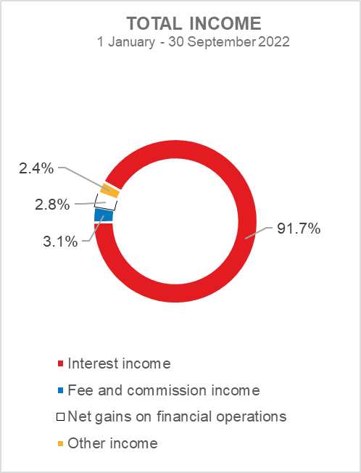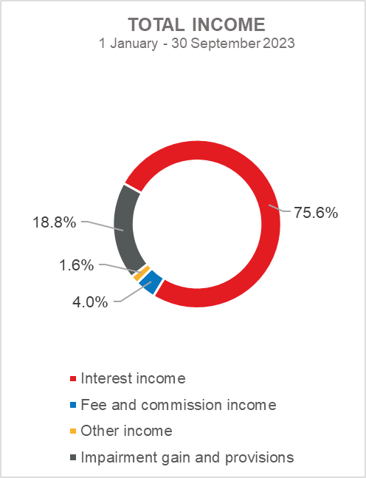

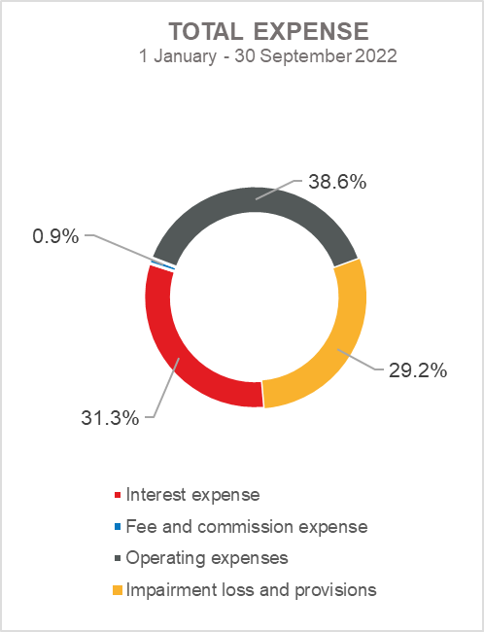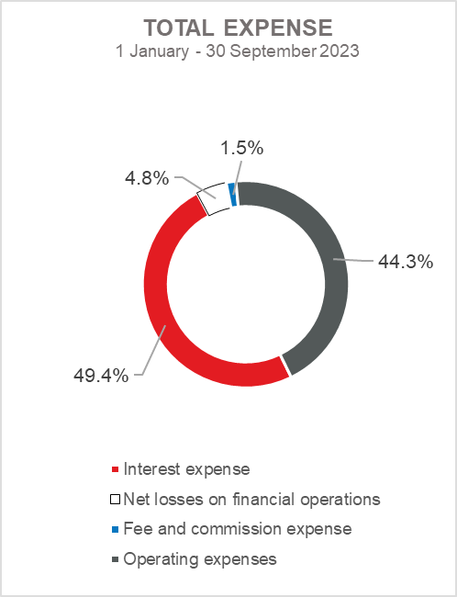

Net interest income

Net interest income amounted to EUR 48.5 million, an increase of 2.3 percent on the same period of the previous reporting year.

Interest income amounted to EUR 68.1 million, an increase of 7.9 percent on the same reporting period last year due to the increase in the volume of lending activities and interest rates.

Interest expenses amounted to EUR 19.6 million, an increase of 24.8 percent on the same reporting period last year, which is the result of growth of borrowings and rise in interest rates.

Given the described trends, a larger increase in interest income than an increase in interest expenses affected the increase in net interest margin compared to the same reporting period of the previous year that amounts to 1.72 percent, while in the same period of the previous year it amounted to 1.66 percent.

Net fee income and commission income

Net fee and commission income amounted to EUR 3.0 million, an increase of 76.5 percent compared with the same period last year due to an increase in income from fees and commissions for transactions in the name and for the account due to the increase in the volume of these transactions.

Net gains/(losses) on financial operations

Net gains/(losses) on financial operations are comprised of net foreign exchange gains/(losses) on the principal amount of receivables and liabilities, gains/(losses) arising out of value adjustment of financial assets stated at fair value through profit or loss and realised gains/(losses) arising out of financial assets at fair value through other comprehensive income.

In the reporting period, net losses from financial activities amounted to EUR 1.9 million, whereas in the same reporting period previous year, net gains amounted to EUR 2.0 million.
A breakdown of changes in the exchange rate of the euros against the USD:

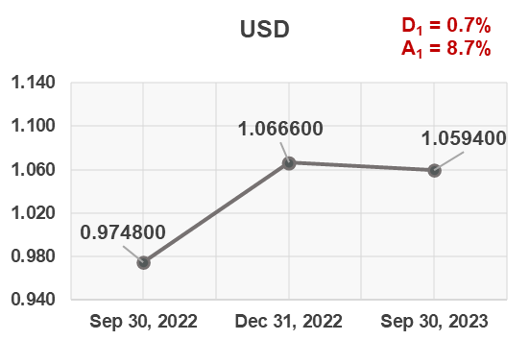

Note:
D₁ = EUR appreciation 30.9.2023/31.12.2022
A₁ = EUR appreciation 30.9.2023/30.9.2022

Funds and sources of funds that are denominated in another currency or are indexed to the currency clause are converted by HBOR into the equivalent value in EUR at the middle exchange rate of HBOR or another agreed exchange rate on the reporting date.

Revenues and expenditures in another currency are converted at the exchange rate on the transaction date. The resulting foreign exchange gains or losses are recorded in the Profit or Loss Account in net figures.

Operating expenses

Operating expenses that include general and administrative expenses and other operating expenses stood at EUR 17.6 million, a decrease of 8.8 percent compared with the same reporting period last year, mainly due to a decrease in other expenses in the amount of EUR 3.3 million as a result of recalculation under financial instruments.

On 30 September 2023, HBOR had 409 employees (on 30 September 2022: 378 employees).

Impairment gain/(loss) and provisions

In the reporting period, a net gain from impairment of placements in the amount of EUR 17.0 million was recorded (in the period 1 January – 30 September 2022: net loss in the amount of EUR 14.6 million).

The text to follow contains a breakdown of portfolio quality:

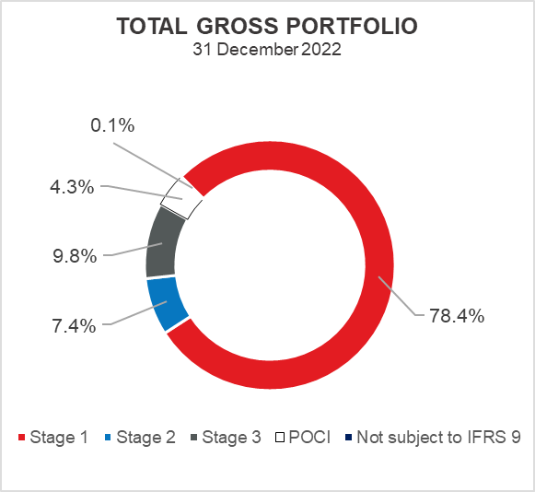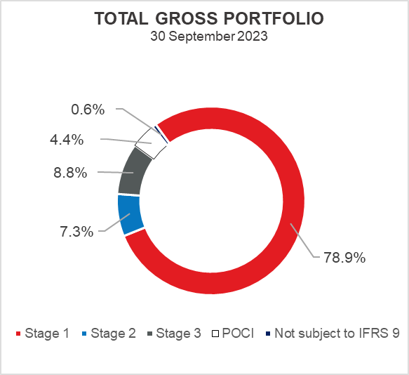

Overview of total gross portfolio and provisions by structure – financial institutions and direct

 | 2022 |  | 30 September 2023
 | In EUR  millions | Breakdown  (percent) | In EUR millions | Breakdown  (percent)
Total gross portfolio | 4,708.8 | 100.0 | 4,897.7 | 100.0
Of which:
- financial institutions | 1,323.3 | 28.1 | 1,457.8 | 29.9
- direct | 3,385.5 | 71.9 | 3,421.9 | 70.1
Total provisions | 482.8 | 100.0 | 473.5 | 100.0
Of which:
- financial institutions | 9.1 | 1.9 | 8.8 | 1.9
- direct | 473.7 | 98.1 | 464.7 | 98.1
Provisions/gross portfolio | 10.3 percent | - | 9.7 percent | -

.
Significant changes in financial position

Total assets of HBOR as at 30 September 2023 amounted to EUR 3,938.3 million, an increase of 2.2 percent compared with 31 December 2022 due to the increase in loans and financial assets at fair value through profit or loss.
Cash on hand and deposits with other banks

As at 30 September 2023, cash on hand and deposits with other banks amounted to EUR 159.4 million representing 4.0 percent of total assets, a decrease of 30.5 percent compared with 31 December 2022 as a result of reallocation of liquidity reserve funds.

Loans to financial institutions and other customers

As at 30 September 2023, total net loans amounted to EUR 3,423.8 million representing 86.9 percent of total assets, an increase 5.8 percent on the beginning of the year.

Total gross loans amounted to EUR 3,878.2 million, an increase of 4.7 percent compared with 31 December 2022. Gross loans to other customers increased by 1.6 percent compared with the end of 2022. Gross loans to financial institutions increased by 14.0 percent compared with the end of 2022 due to the increase in placements under new loan programmes, framework loans to leasing companies and short-term placements.
.
As at 30 September 2023 the proportion between gross loans on-lent through financial institutions and direct placements stood at 27 percent : 73 percent (31 December 2022: 25 percent : 75 percent).

Financial assets at fair value through profit or loss

Loans at fair value (HBOR has determined that mezzanine loans are classified here), investments in investment funds and a part of equity instruments are classified to these assets. As at 30 September 2023, the total amount of these assets was EUR 49.8 million representing 1.3 percent of total assets and the increase is the result of a new mezzanine loan.

Financial assets at fair value through other comprehensive income

a) Debt instruments

Bonds of the Republic of Croatia and treasury bills of the Ministry of Finance as part of liquidity reserve as well as bonds of a company are classified to these assets. On the reporting date, they amounted to EUR 275.4 million, representing 7.0 percent of total assets and recorded a decrease compared to the beginning of the year by 19.8 percent.
The impairment of these financial assets is calculated through the application of the model of expected credit losses in the manner that provisions are recognised in the accounts of other comprehensive income, thus not reducing the carrying amount of these financial assets in the statement on financial position. On the reporting date, they amounted to EUR 0.5 million in other reserves.
b) Equity instruments

Equity instruments (shares of companies) that HBOR does not intend to sell and to which irrevocable option of subsequent measurement of fair value through other comprehensive income without recycling is applied are classified to these assets, i.e. reserves recognised under other comprehensive income will never be transferred to the statement on profit or loss.
On the reporting date, these assets amounted to EUR 7.8 million, representing 0.2 percent of total assets.

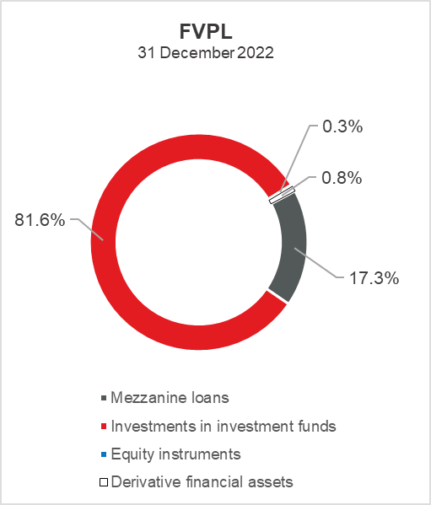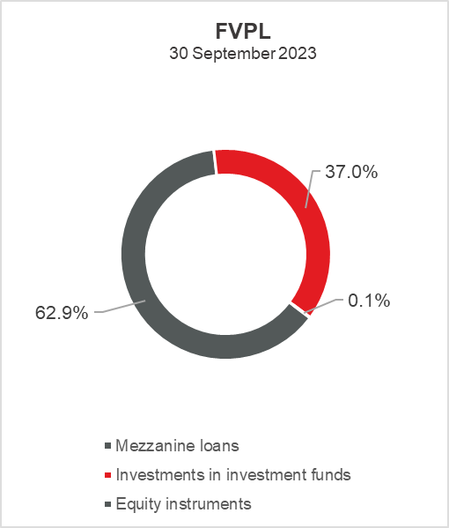

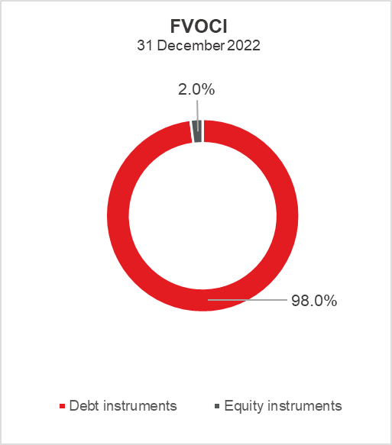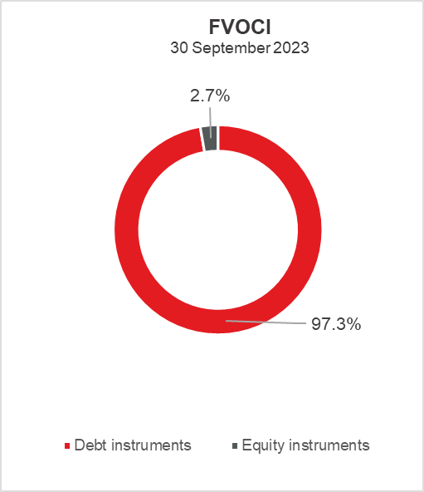

Total liabilities

As at 30 September 2023, total liabilities amounted to EUR 2,465.6 million, which represents 62.6 percent of total liabilities and total equity. The major part of total liabilities consists of HBOR’s borrowings in the total amount of EUR 2,172.2 million.

Borrowings decreased by 0.8 percent compared with the beginning of the year, whereas changes in these liabilities are shown in the following table:

 | (in millions of euros)
- Draw-down of funds borrowed under previously contracted  funds of special financial institutions | 269.0
- Repayments of borrowings | (289.3)
- Foreign exchange gains or losses | 0.1
- Other calculations * | 2.3
Total changes | (17.9)
* Other calculations relate to changes in amount of interest not due and deferred fees.

Total equity

Total equity amounted to EUR 1,472.7 million, representing 37.4 percent of total liabilities and total equity.

Total equity of HBOR is comprised of the capital and the guarantee fund. HBOR’s capital is comprised of founder’s capital contributed from the budget of the Republic of Croatia, retained earnings from the profits generated in the previous years, other reserves and profits for the current period.

The total amount of capital contributed from the budget of the Republic of Croatia stood at EUR 899.6 million, and the remaining amount to be contributed to the founder’s capital up to the total amount of EUR 929.1 million set by the HBOR Act is EUR 29.5 million

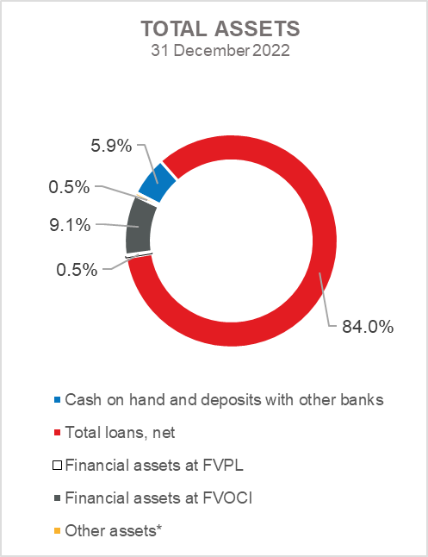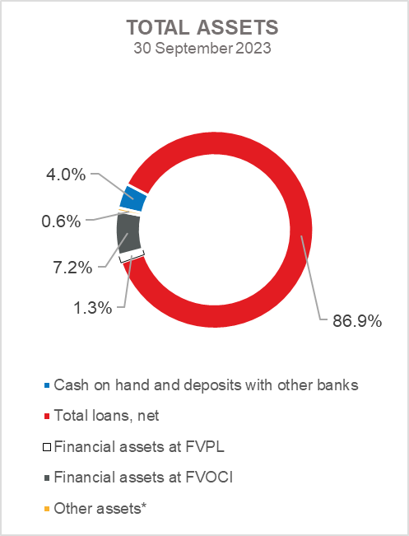

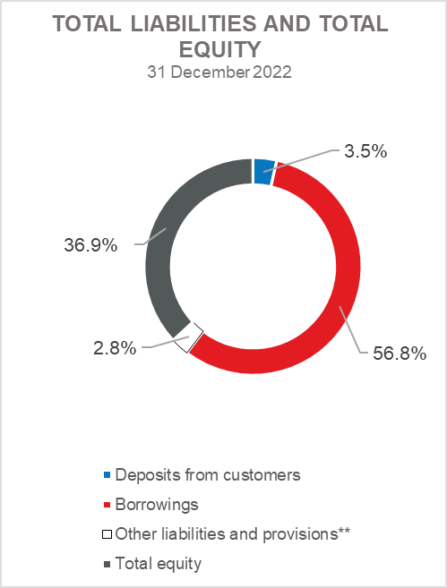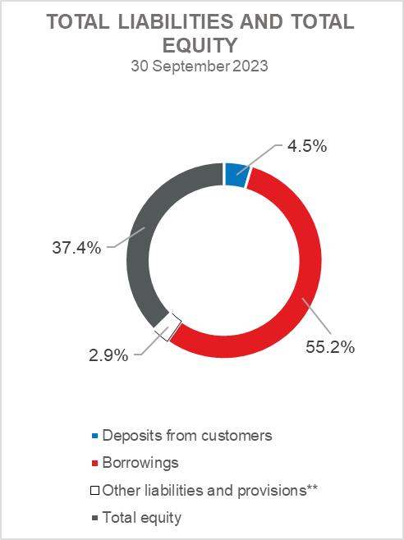

*Investments in subsidiaries, Property, plant and equipment and intangible assets, Foreclosed assets and Other assets.
** Provisioning includes provisioning for guarantees, commitments and other liabilities.

